# 运行截图

turtle

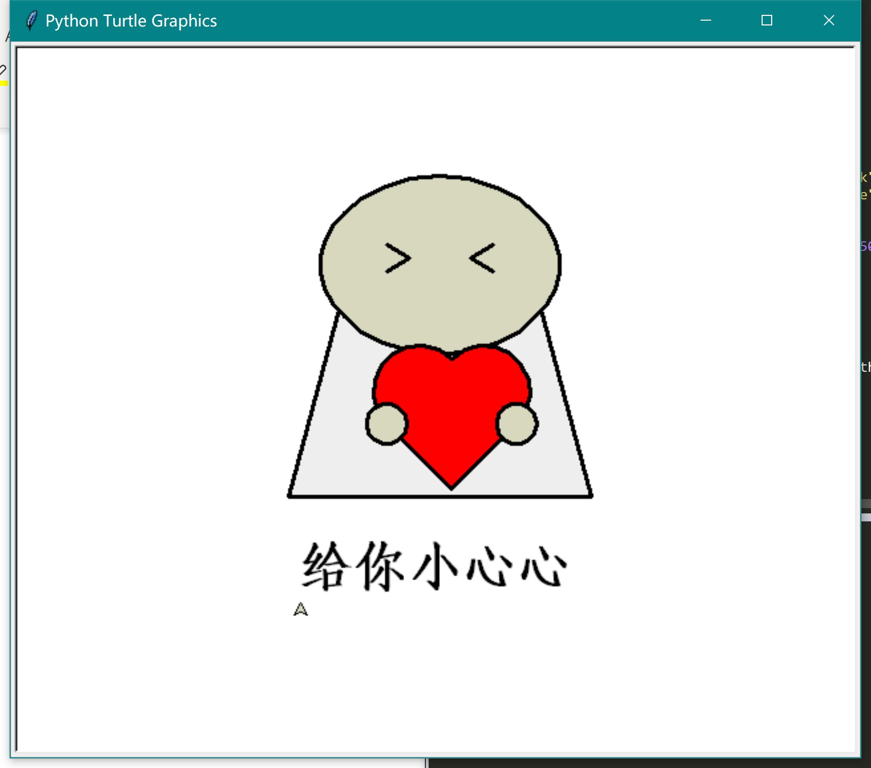

条形图

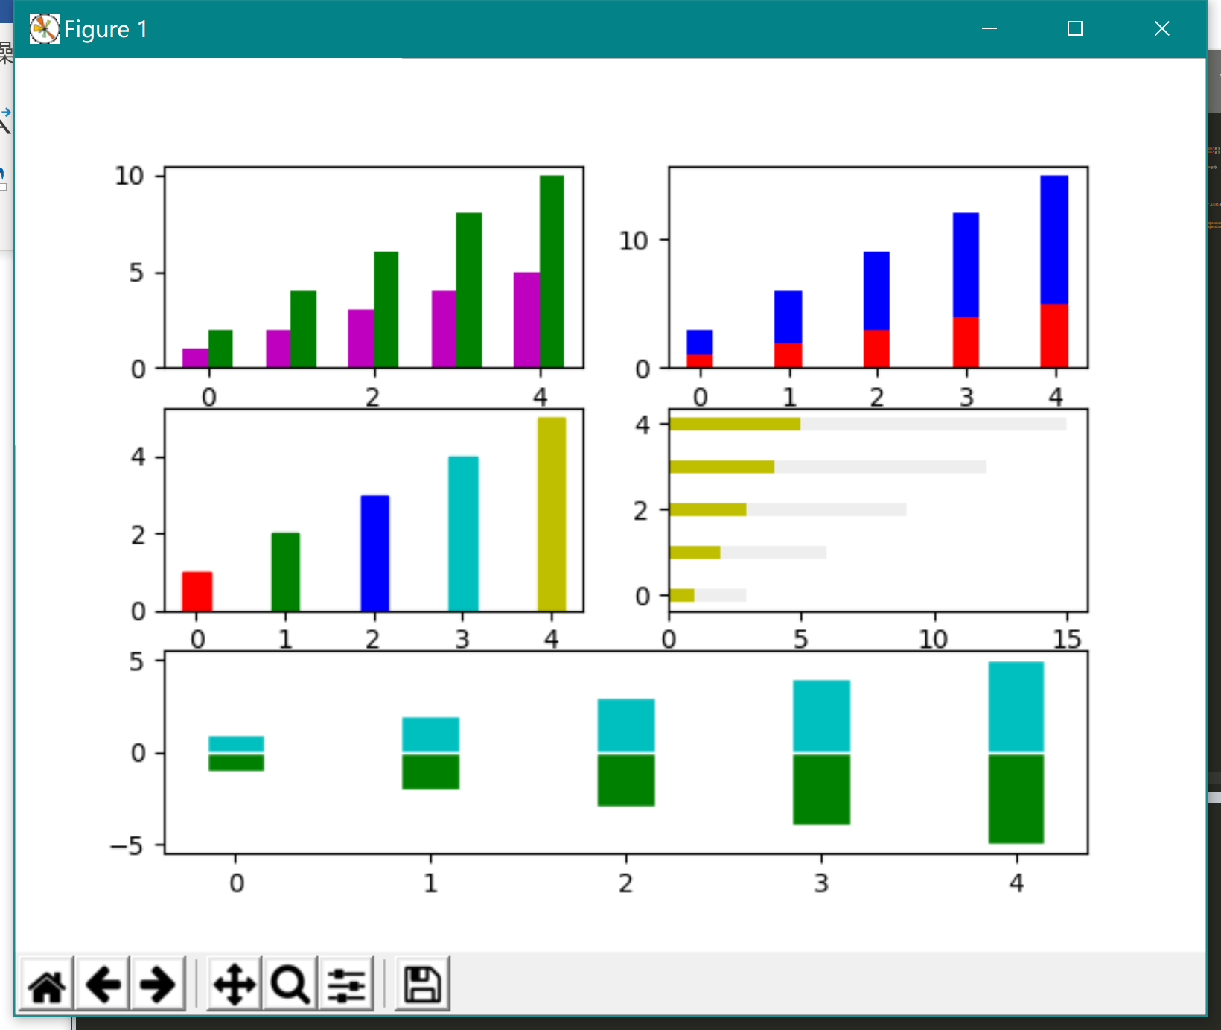

散点图

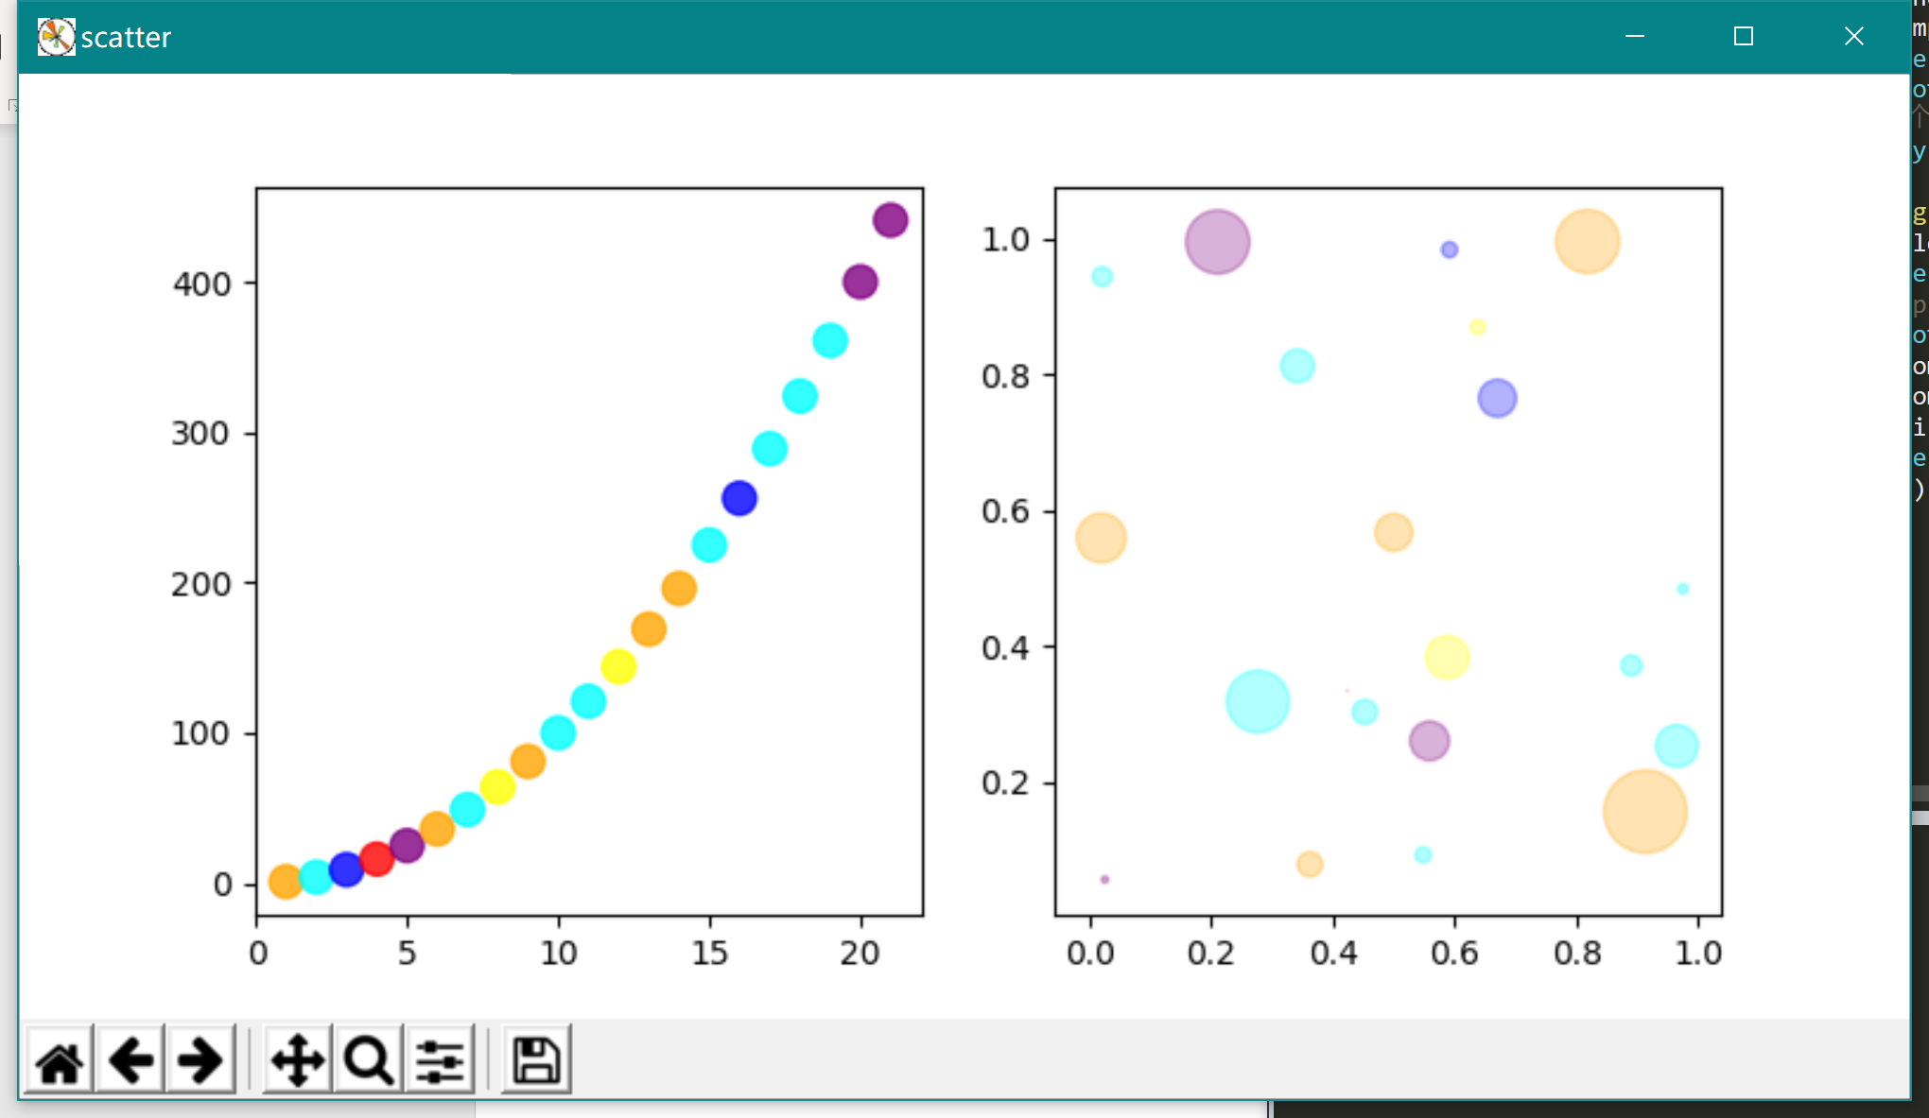

饼图

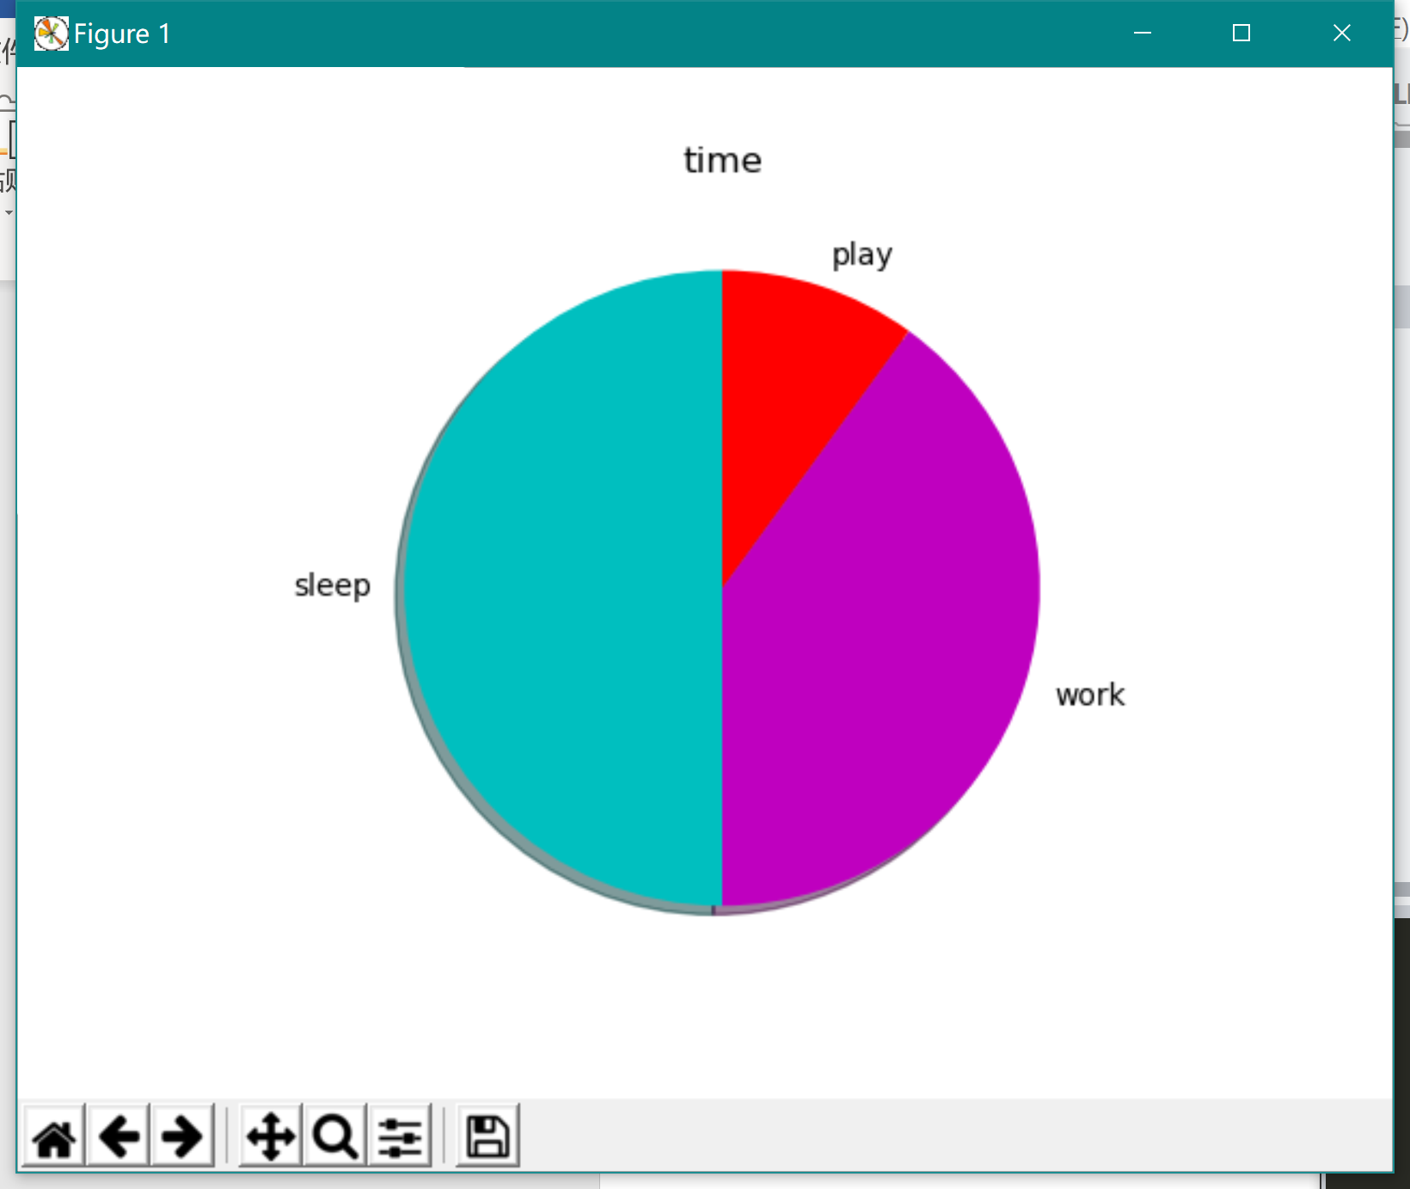

# 源代码

## turtle

|  |  |
| --- | --- |
| 1 | import turtle |
| 2 | import math |
| 3 | size=1.5 |
| 4 | PosX=0 |
| 5 | PosY=0 |
| 6 |  |
| 7 | pen=turtle.Pen() |
| 8 | pen.pensize(3) |
| 9 | pen.pencolor("black") |
| 10 | pen.fillcolor("#eee") |
| 11 | #身体 |
| 12 | pen.up() |
| 13 | pen.goto(-50*size,50*size) |
| 14 | pen.down() |
| 15 | pen.begin_fill() |
| 16 | pen.fd(100*size) |
| 17 | pen.rt(75) |
| 18 | pen.fd(100*size) |
| 19 | pen.rt(105) |
| 20 | pen.fd(100*size*math.sin(15/180*math.pi)*2+100*size) |
| 21 | pen.rt(105) |
| 22 | pen.fd(100*size) |
| 23 | pen.end_fill() |
| 24 | # 头 |
| 25 | pen.up() |
| 26 | pen.home() |
| 27 | pen.down() |
| 28 | pen.fillcolor("#D8D8BF") |
| 29 | pen.begin_fill() |
| 30 | pen.up() |
| 31 | pen.goto(0*size,25*size) |
| 32 | pen.down() |
| 33 | radius=75*size |
| 34 | pen.circle(radius,180/8) |
| 35 | pen.circle(radius*0.8,180/8) |
| 36 | pen.circle(radius*0.6,180/8) |
| 37 | pen.circle(radius*0.4,180/4) |
| 38 | pen.circle(radius*0.6,180/8) |
| 39 | pen.circle(radius*0.8,180/8) |
| 40 | pen.circle(radius,180/4) |
| 41 | pen.circle(radius*0.8,180/8) |
| 42 | pen.circle(radius*0.6,180/8) |
| 43 | pen.circle(radius*0.4,180/4) |
| 44 | pen.circle(radius*0.6,180/8) |
| 45 | pen.circle(radius*0.8,180/8) |
| 46 | pen.circle(radius,180/8) |
| 47 | pen.end_fill() |
| 48 | #眼睛 |
| 49 | pen.up() |
| 50 | pen.goto(-80*size/3,80*size) |
| 51 | pen.down() |
| 52 | pen.rt(30) |
| 53 | pen.fd(20/1.5*size) |
| 54 | pen.rt(120) |
| 55 | pen.fd(20/1.5*size) |
| 56 | pen.up() |
| 57 | pen.goto(80*size/3,80*size) |
| 58 | pen.down() |
| 59 | pen.fd(20/1.5*size) |
| 60 | pen.lt(120) |
| 61 | pen.fd(20/1.5*size) |
| 62 | #爱心 |
| 63 | pen.fillcolor("red") |
| 64 | pen.begin_fill() |
| 65 | pen.up() |
| 66 | pen.goto(-80*size/3,-10*size) |
| 67 | pen.down() |
| 68 | pen.setheading(135) |
| 69 | pen.circle(-23*size,180) |
| 70 | pen.lt(90) |
| 71 | pen.circle(-23*size,180) |
| 72 | pen.fd(46*size) |
| 73 | pen.rt(90) |
| 74 | pen.fd(46*size) |
| 75 | pen.end_fill() |
| 76 | #左手+右手 |
| 77 | pen.fillcolor("#D8D8BF") |
| 78 | pen.begin_fill() |
| 79 | pen.up() |
| 80 | pen.goto(-80*size/3+10*size,-10*size) |
| 81 | pen.down() |
| 82 | pen.setheading(90) |
| 83 | pen.circle(10*size,360) |
| 84 | pen.end_fill() |
| 85 | pen.begin_fill() |
| 86 | pen.up() |
| 87 | pen.goto(-80*size/3+10*size+46*size*math.sqrt(2),-10*size) |
| 88 | pen.down() |
| 89 | pen.setheading(90) |
| 90 | pen.circle(10*size,360) |
| 91 | pen.end_fill() |
| 92 | #文字 |
| 93 | pen.up() |
| 94 | pen.goto(-70*size,-100*size) |
| 95 | pen.down() |
| 96 | pen.write('给你小心心',*font*=("Courier",30,"bold")) |
| 97 | turtle.mainloop() |

## bar

|  |  |  |  |  |  |  |  |  |  |  |  |  |  |  |  |  |  |  |  |  |  |  |  |  |  |  |  |  |  |  |  |  |  |  |  |  |  |  |  |  |  |  |  |  |  |  |  |  |  |  |  |  |  |  |  |  |  |  |  |  |  |  |  |  |  |  |  |
| --- | --- | --- | --- | --- | --- | --- | --- | --- | --- | --- | --- | --- | --- | --- | --- | --- | --- | --- | --- | --- | --- | --- | --- | --- | --- | --- | --- | --- | --- | --- | --- | --- | --- | --- | --- | --- | --- | --- | --- | --- | --- | --- | --- | --- | --- | --- | --- | --- | --- | --- | --- | --- | --- | --- | --- | --- | --- | --- | --- | --- | --- | --- | --- | --- | --- | --- | --- |
| |  |  | | --- | --- | | 1 | import numpy as np | | 2 | import matplotlib.pyplot as plt | | 3 |  | | 4 | y1 = [1, 2, 3, 4, 5] | | 5 | y2 = [2, 4, 6 ,8,10] | | 6 | index = np.arange(5) | | 7 | bar_width = 0.3 | | 8 | #双层 | | 9 | plt.subplot(3,2,1) | | 10 | plt.bar(index-bar_width/2, y1, bar_width , *color*='m') | | 11 | plt.bar(index+bar_width/2, y2, bar_width , *color*='g') | | 12 | #带底部 | | 13 | plt.subplot(3,2,2) | | 14 | plt.bar(index, y1, bar_width , *color*='r') | | 15 | plt.bar(index, y2, bar_width , *color*='b',*bottom*=y1) | | 16 | #五彩 | | 17 | plt.subplot(3,2,3) | | 18 | color=['r','g','b','c','y'] | | 19 | bars=plt.bar(index, y1, bar_width ) | | 20 | for i,color in enumerate(color): | | 21 | bars[i].set_color(color) | | 22 | #水平 | | 23 | plt.subplot(3,2,4) | | 24 | plt.barh(index, y1, bar_width , *color*='y') | | 25 | plt.barh(index, y2, bar_width , *color*='#eeeeee',*left*=y1) | | 26 | #倒影 | | 27 | plt.subplot(3,1,3) | | 28 | y2=[-i for i in y1] | | 29 | print(y2) | | 30 | plt.bar(index, y1, bar_width , *facecolor*='c',*edgecolor*='white') | | 31 | plt.bar(index, y2, bar_width , *facecolor*='g',*edgecolor*='white') | | 32 | ax=plt.gca() | | 33 | plt.show() | |  |

## scatter

|  |  |
| --- | --- |
|  | |
| |  |  | | --- | --- | | 1 | import matplotlib.pyplot as plt | | 2 | import random | | 3 | import numpy as np | | 4 | plt.figure("scatter",*figsize*=(8,4)) | | 5 | plt.subplot(1,2,1) | | 6 | n=21#点的个数 | | 7 | x=np.array([x for x in range (1,n+1)]) | | 8 | y=x*x | | 9 | colors=['green','yellow','red','blue','orange','purple','cyan'] | | 10 | random_colors=np.random.choice(colors,n,*replace*="true") | | 11 | plt.scatter(x,y,*s*=100,*c*=random_colors,*alpha*=0.8) | | 12 | # plt.subplot(2,1,2) | | 13 | plt.subplot(1,2,2) | | 14 | x=np.random.rand(n) | | 15 | y=np.random.rand(n) | | 16 | area=np.pi*(15*np.random.rand(n))**2 | | 17 | plt.scatter(x,y,*s*=area,*c*=random_colors,*alpha*=0.3) | | 18 | plt.show() | |  |

## pie

|  |  |  |  |  |  |  |  |  |  |  |  |  |  |  |  |  |
| --- | --- | --- | --- | --- | --- | --- | --- | --- | --- | --- | --- | --- | --- | --- | --- | --- |
| |  |  |  |  |  |  |  |  |  |  |  |  |  |  |  |  | | --- | --- | --- | --- | --- | --- | --- | --- | --- | --- | --- | --- | --- | --- | --- | --- | | |  |  | | --- | --- | | 1 | import matplotlib.pyplot as plt | | 2 | slices = [50,40,10] | | 3 | day= ['sleep','work','play'] | | 4 | cols = ['c','m','r'] | | 5 | plt.pie(slices,*labels*=day,*colors*=cols,*startangle*=90,*shadow*= True) | | 6 | plt.title('time') | | 7 | plt.show() | |  | |
|  |
|  |
|  |
|  |
|  |
|  |
|  |
|  |
|  |
|  |
|  |
|  |
|  |
|  |
|  |
|  |
|  |